DEAR HARVEST HELPERS – DOWNLOAD THE NEW BOX TOPS APP!
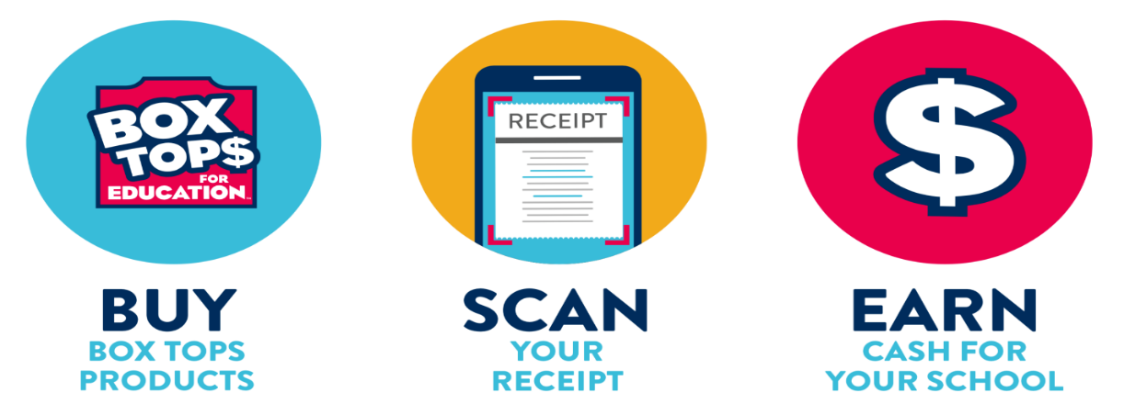
https://www.boxtops4education.com/ set up Harvest as your donation school
When you see these….
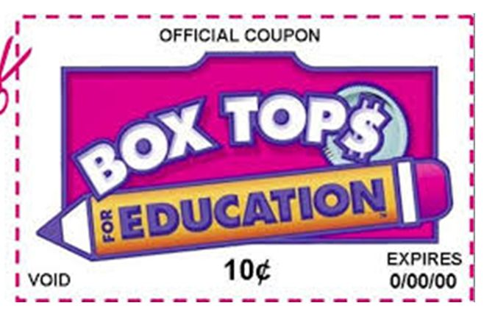
Scan your grocery receipt into the app within 14 days.
When you see these….
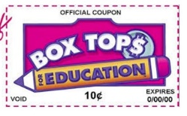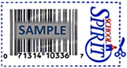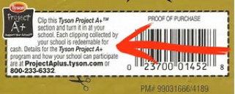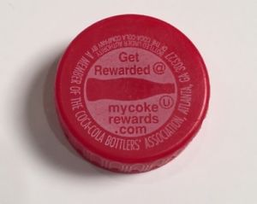
Send them to school for manual processing. 1st Deadline 15Oct19
Yes – we can earn double if you scan AND send in the Box Tops with an expiration date!
Don’t forget to choose our school for the Amazon Smile Program https://org.amazon.com/
Bush’s My Way Program https://www.buschs.com/account/login
Kroger Rewards Program https://www.kroger.com/account/enrollCommunityRewardsNow/
And the Coke Rewards Program https://us.coca-cola.com/give/schools/

